Title: The Indigenous Foundation of the Iranian Plateau and the Late Arrival of Steppe Pastoralists: A Multidisciplinary Analysis of the Bactria-Margiana Archaeological Complex and Airyanem Vaejah
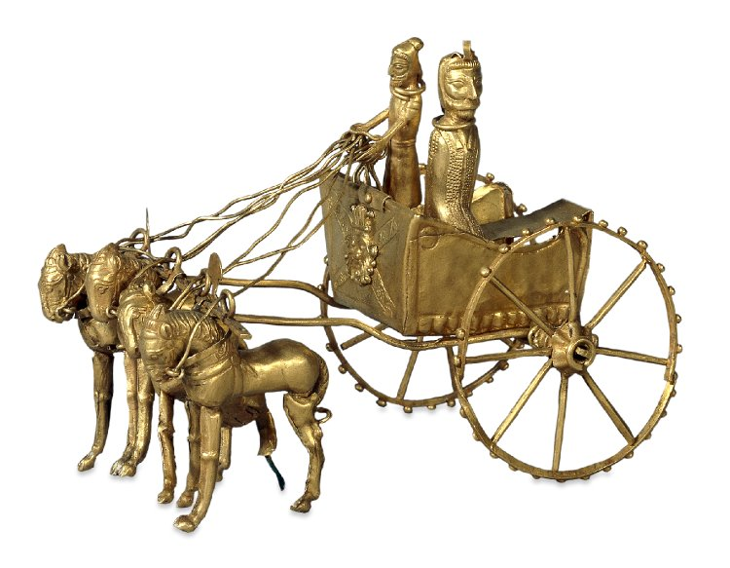
Abstract
This article synthesizes genomic data, archaeological evidence, and historical linguistics to establish a definitive chronology of the Iranian Plateau’s dem۔ographic and civilizational formation. The evidence demonstrates that the Bactria-Margiana Archaeological Complex (BMAC) and the sacred geography of Airyanem Vaejah (centered in the Bamiyan region and the Hindu Kush) were founded by an indigenous Neolithic population carrying the Y-chromosome haplogroup J2a. This population domesticated plants and animals, developed irrigation agriculture, and created the material and conceptual foundations of the Avestan tradition. The Steppe pastoralists, characterized by haplogroup R1a-Z93, arrived millennia later during the Bronze Age and Early Iron Age. Genomic surveys establish that modern Pashtun populations, carrying R1a-Z93 at frequencies exceeding 51%, represent the genetic legacy of this late Steppe migration. The Steppe migrants introduced the Indo-Iranian language and the chariot. The civilizational, agricultural, and religious substance of the BMAC and Airyanem Vaejah remained indigenous. The Avestan and Old Persian languages absorbed a vast substrate vocabulary from the BMAC civilization, proving that the Steppe element contributed to the linguistic framework while the indigenous population built the civilization.

1. Introduction

The demographic and civilizational history of the Iranian Plateau demands a strict analytical separation between the architects of its first complex societies and the mobile pastoralists who arrived millennia later. Recent advances in ancient DNA (aDNA), archaeological chronology, and historical linguistics provide the empirical foundation for this separation. The genomic record establishes a clear sequence: an indigenous Neolithic substrate (J2a) constructed the BMAC and the sacred geography of Airyanem Vaejah; a Steppe pastoralist population (R1a-Z93) arrived during the Middle to Late Bronze Age, superimposing a new language and a militarized social order onto this pre-existing civilization. This article synthesizes the primary data from population genetics, archaeology, and linguistics to demonstrate that the claim of absolute indigenous status for the Pashtun population contradicts the established scientific record.

2. The Indigenous Neolithic Foundation: BMAC and Airyanem Vaejah

The Bactria-Margiana Archaeological Complex (BMAC), also known as the Oxus Civilization, flourished in southern Central Asia and northern Afghanistan from approximately 2250 to 1700 BCE. This civilization was fundamentally sedentary and agricultural. Its inhabitants practiced irrigation farming of wheat and barley, constructed large-scale irrigation systems, and domesticated the Bactrian camel around 2500 BCE, prior to the civilization’s peak. Archaeological excavations reveal monumental architecture, fortified settlements, and a sophisticated material culture that was not the product of nomadic pastoralists.

Genomic analysis provides the definitive evidence for the ethnic and genetic identity of the BMAC population. The 2019 Science study by Narasimhan et al. analyzed genome-wide ancient DNA from BMAC individuals and established a critical fact: the main BMAC population carried no Steppe pastoralist ancestry. Further analysis of the published per-individual data reveals that the dominant paternal lineage in the BMAC cluster was J2a, particularly J2a1, with no R1a males present in the BMAC sample. The BMAC population derived primarily from preceding local Copper Age peoples, who were in turn descended from Zagros Neolithic farmers. This population was the primary source of ancestry for the peoples of the Bronze Age BMAC.

The geographical and conceptual heartland of this indigenous civilization is Airyanem Vaejah. Scholarly consensus, articulated by Iranologists such as Michael Witzel, locates Airyanem Vaejah in the central highlands of Afghanistan, specifically around the Bamiyan province and the Hindu Kush region. The Vendidad list of sixteen lands was redacted by an individual who regarded Afghanistan and its surrounding territories as the homeland of all Aryans, with Airyanem Vaejah at its center. The Zoroastrian tradition, with its deep reverence for agriculture, animal husbandry, and the domestication of the camel—concepts embedded in the Avestan language through substrate loanwords—reflects the worldview of this indigenous J2a farming population.

3. The Late Steppe Intrusion: R1a-Z93 and the 8th Century BCE

The Steppe pastoralists, associated with the Sintashta and Andronovo cultures, represent a distinct and later demographic event. Haplogroup R1a-Z93 emerged on the Eurasian Steppe approximately 5,000 to 5,500 years ago, splitting from its European sister branch, R1a-Z282. The Sintashta culture (c. 2100–1800 BCE) was characterized by the invention of the spoke-wheeled chariot and horse sacrifice. Every male of the Sintashta culture analyzed to date carried R1a-Z93, as did the related Andronovo and Srubnaya peoples.

Ancient DNA confirms that R1a-Z93 was absent from the Iranian Plateau and South Asia before the Bronze Age. The lineage appears in South Asian remains only after approximately 2000 to 1500 BCE, precisely when Steppe ancestry arrives in the region. The migration of Steppe pastoralists onto the Iranian Plateau is documented in historical records by the 8th century BCE. The ancestors of the Parthians, for instance, were Steppe tribes who moved southward into the Iranian plateau from the Southern Urals and the Khorezm region. By the 1st millennium BCE, Iranian-speaking peoples including the Medes, Persians, Bactrians, and Parthians populated the Iranian plateau, arriving from the Central Asian steppes.

The genomic profile of modern Afghan populations provides the direct link to this late Steppe migration. The 2012 PLOS ONE study by Haber et al. analyzed 204 unrelated males from Afghanistan’s four major ethnic groups using 52 binary markers and 19 short tandem repeats. The results are unambiguous. Haplogroup R1a1a-M17 is present at 51.02% in Pashtuns and 30.36% in Tajiks. In contrast, the frequency of R1a1a-M17 in the indigenous Hazara (Āzrah) population is only 6.67%. The Pashtun population, therefore, carries the genetic signature of the late Steppe pastoralists at a frequency exceeding fifty percent, establishing their demographic origin as a post-BMAC overlay.

4. Language, Civilization, and the BMAC Substrate

The Steppe pastoralists introduced the Indo-Iranian language family and the chariot. The genetic evidence demonstrates a strongly male-biased admixture process: Steppe men integrated with indigenous women, resulting in a high frequency of R1a-Z93 on the Y-chromosome, while the autosomal DNA of modern populations remains predominantly indigenous. The Steppe migrants did not build the cities, dig the irrigation canals, or compose the original agricultural hymns of the Avesta.

The linguistic evidence confirms this civilizational hierarchy. The Proto-Indo-Iranian language absorbed a substantial body of loanwords from the language of the BMAC people. These loanwords include fundamental terms for BMAC material culture and agriculture: išt(i)- ‘brick’, jaujiā- ‘canal’, uštra- ‘camel’, and khara- ‘donkey’. The word for ‘camel’ in particular has no plausible Indo-Iranian or Indo-European etymology, confirming its origin in the BMAC substrate. The Steppe element provided the linguistic framework; the BMAC and J2a populations provided the civilizational, agricultural, and religious substance. The data establishes that the claim of absolute indigenous status for the Pashtun population contradicts the established genetic and archaeological record. The true civilizational foundation of the Iranian Plateau belongs to the descendants of the indigenous J2a farmers, whose genetic and cultural legacy remains intact in populations such as the Āzrah (Hazaras), who carry the Neolithic Iranian farmer lineage J2a1-Page55 at a frequency of 13%, second only to Iran.

5. Conclusion

The scientific data from Y-chromosome phylogenetics, ancient DNA, archaeology, and historical linguistics establishes a definitive chronology. The indigenous Neolithic farmers carrying haplogroup J2a built the BMAC, domesticated the Bactrian camel, developed irrigation agriculture, and laid the material and conceptual foundations of Airyanem Vaejah and the Avestan tradition. The Steppe pastoralists carrying haplogroup R1a-Z93 arrived millennia later, bringing the chariot and the Indo-Iranian language. The modern Pashtun population, carrying R1a-Z93 at frequencies exceeding 51%, represents the genetic legacy of this late Steppe migration. The data demonstrates that the claim of absolute indigenous status for the Pashtun population contradicts the established genetic and archaeological record. The civilizational foundation of the Iranian Plateau belongs to the descendants of the indigenous J2a farmers.

References

1. Narasimhan, V.M., et al. (2019). The formation of human populations in South and Central Asia. Science, 365(6457), eaat7487.
2. Haber, M., et al. (2012). Afghanistan's Ethnic Groups Share a Y-Chromosomal Heritage Structured by Historical Events. PLOS ONE, 7(3), e34288.
3. Witzel, M. (2000). The Home of the Aryans. In A. Hinze & E. Tichy (Eds.), Festschrift J. Narten (pp. 283–338). Dettelbach: J.H. Röll.
4. Di Cristofaro, J., et al. (2013). Afghan Hindu Kush: Where Eurasian Sub-Continent Gene Flows Converge. PLOS ONE, 8(10), e76748.
5. Lubotsky, A. (2001). The Indo-Iranian Substratum. In C. Carpelan et al. (Eds.), Early Contacts between Uralic and Indo-European. Helsinki: Suomalais-Ugrilainen Seura.

